OKLAHOMA BUSINESS ETHICS CONSORTIUM
Oklahoma City Chapter ~ May 14, 2008
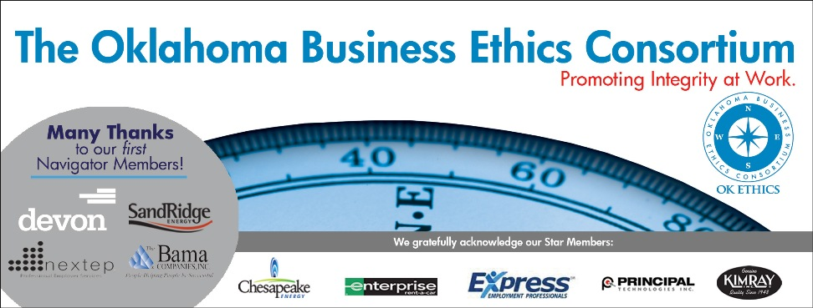
VISION: To be recognized as a statewide (and national)
forum for promoting business ethics.

- KUDOS & WELCOME Garyl Geist, CEO of Valir Health, Member of OkEthics Board of Directors
Guiding Principle: HONOR
We express gratefulness to our hosts, sponsors and speakers.
Gratitude is not only the greatest of all virtues, but the parent of all others.
– Cicero
  - Tony Blasier of Chesapeake Energy for organizing today’s program.
  - Greg Byers of Sinclair Broadcasting Group – Every month, Greg is in charge of making sure that the registration process goes smoothly. We depend on Greg’s conscientious attention to detail and sense of hospitality in making our guests feel welcome every month.
  - Mary Kay Huggard & the Principal Technologies team for their reliability in making themselves available to help our guests and members with registrations. We appreciate their generosity of time.
  - Joshua Jantz of IBLP for preparing and organizing our name tags every month.
  - Connie Barwick – Maximum Multi Media Creations for the pre-meeting Power Point presentations and website.
  - Tess Smith – Walker Companies for donating the great OkEthics banner.
  - Behind the scenes, our dedicated volunteers who serve on the Board and are the heart of this organization!

Welcome visitors: The Hertz Corporation

Please help promote Oklahoma values of integrity at work:
Join OkEthics by going online to www.okethics.org

- CONGRATS TO OUR COMPASS AWARDS HONOREES!
Bob Byrne, Ethics Advisor, Boeing; President of the OkEthics Foundation
  - See best practices at www.okethics.org for shared information
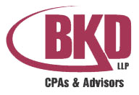 |  | 
Previous recipients include:
  - 2006: Valir Health, Eide Bailly LLP
  - 2007: Boeing, The Bama Companies, Coppermark Bank and Nextep, Inc.

III. INTRODUCTION OF GUEST SPEAKERS Tony Blasier, Director of Corporate Security & Ethics,
Chesapeake Energy Corporation

Attorney General Panelists:

  - Larry Derryberry
  - Susan Loving
  - Mike
Turpen

IV. UPCOMING EVENTS Shannon Hiebert, Vice President of Human Resources,
Enterprise Rent-a-Car,
President of the OkEthics Consortium
Advance reservations required for all events ~
Visit our website at www.okethics.org or call 858-2233;
Member discounts apply regardless of location.
Norman Chapter –
June 18 – Stillwater Sheriff Norman McNickle, “Decisions: Right, Wrong or Ethical”

OKC Chapter
June 11 - "The People Factor" –
Discussion of Ethical Dilemmas from the Human Resources Perspective

At this year's Compass Awards, we told you that managing ethics in the workplace can best be described as a "Jungle". Well, imagine how challenging that jungle gets when you add the "People Factor". For the first time, we have four generations in the workplace which adds a whole different paradigm when it comes to ethics in the workplace. The four panelist will discuss the biggest ethical challenges they face in their respective industries and how "the people factor" factors in.

Tere Bettis, Vice President
Director of Human Resources
Coppermark Bank

Carolyn Shockey, PHR
Director of Human Resources
Norman Regional Hospital

Jeanette Rice, Senior Vice President
Corporate and Human Resources
American Fidelity Assurance

Moderator:
Shannon Hiebert

Tulsa Chapter
May 22 – “How Good People Turn Evil” panel discussion
June 26 – Clifton Taulbert

V. OTHER RELATED PROGRAMS:

Character First Institute - May 29 & June 2 – “Wisdom in the Workplace”

Oklahoma City Business and Community Leaders' Luncheon

Registration Information: Call 815-0001, or visit www.characterok.org

OkEthics is very grateful for the support of over 600 individual members statewide:
For a complete listing of sponsors, please visit our website at www.okethics.org
See also additional sponsors listed on our website.

NAVIGATOR MEMBERS – $7500 level
- BAMA COMPANIES (Tulsa)
- DEVON Energy
- NEXTEP (Norman)
- SANDRIDGE ENERGY
Many thanks to our Navigator sponsors for their continued support! Shows support at highest level of commitment in terms of funding ($7500) and participation.

OKLAHOMA STAR MEMBERS
-- $5000 level
- Chesapeake Energy
- Express Personnel Services
- Enterprise Rent-A-Car
- Kimray, Inc.
- Principal Technologies
The Oklahoma Star membership of $5000 Includes 8 memberships; prepaid for all OkEthics events. Shows support by allowing OkEthics to post logo on Home page of website and promotional materials.

HORIZON MEMBERS – $2500 level
Dollar Thrifty Automotive Group (Tulsa); Helmerich & Payne (Tulsa); Norris (Tulsa);
The Rowland Group (Tulsa); Metro Technology Centers (OKC); SemGroup (Tulsa);
Valir Health (OKC)

PLEASE HELP US CONTROL COSTS BY LEAVING YOUR NAME TAG HERE!

General Disclaimer: Members of the Oklahoma Business Ethics Consortium frequently share information concerning various issues and developments that may have legal implications. The discussions, commentary, and handouts at Consortium meetings or presentations to other organizations are for general informational purposes only. They cover only some aspects of the subject topic, and do not constitute a complete legal analysis of the topic or how it might apply to any particular set of facts. Before taking any action based on information presented during a Consortium event, participants are encouraged to consult a qualified attorney. The observations and comments of presenters at Consortium meetings and networking are the views and opinions of the presenter and do not constitute the opinion or policies of the Consortium or any of its members. Presenters are respectfully requested to avoid profanity, preaching, politics and self-promotion during their lectures. It is the responsibility of participants to demonstrate applicability of each program for demonstration of earned CPE credits.

